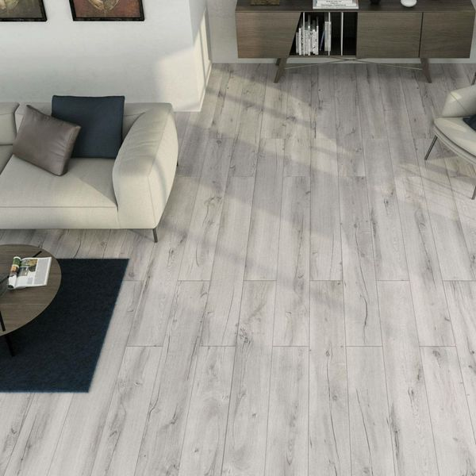**Muniellos Grey Anti-Slip:**

**Product Description**

Made from durable porcelain, these Muniellos Grey Anti-Slip Wood Effect Tiles have a realistic wood effect design and a matt finished, perfect for creating a natural look inside and outside your home! Grey in colour, they are styled to look like silver birch wood, with an R11 anti-slip surface.

**What’s special about these tiles?**

> Durable porcelain

> Suitable for both walls and floors

> Suitable for internal and external use

> Realistic wood effect design

> Natural matt finish

> R11 anti-slip surface

**Try before you buy**

Want to take a closer look at these tiles before placing a full order? Order a sample tile! Samples come full size and with Free Delivery, and they're a great way to get a feel for a tile's size, colour and texture. You can even see how it looks on the wall or floor in your chosen space.

## **Product Info**

* Product ID: 36535
* Tiles Per SQM: 7.4074074074074
* Sale by: Per SQM
* Size: 150x900x10mm
* Weight: 3.18 KG
* Material Type: Porcelain
* Finish: Matt
* Colour: Grey
* Suitability: Floors, Walls
* Grade: 4
* Rectified Edge: Yes
* Underfloor Heating: Yes
* Anti Slip Grade: R11 / 35 Degrees
* Document: [Recommended Layouts](https://m2.wallsandfloors.co.uk/media/amasty/amfile/attach/Extra-long-wood-effect-tiles.pdf)
* Thickness (mm): 10